L.O To consider how changes in the religion of England affected Catholics and Protestants
Read about the beliefs below, then use the information from sessions 1-2 to consider the questions.
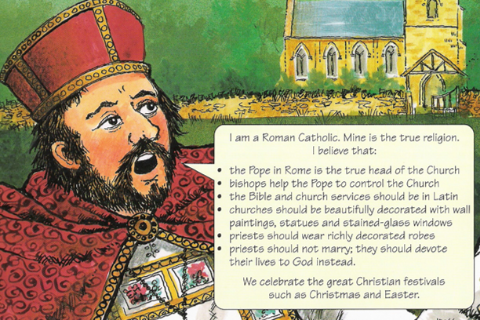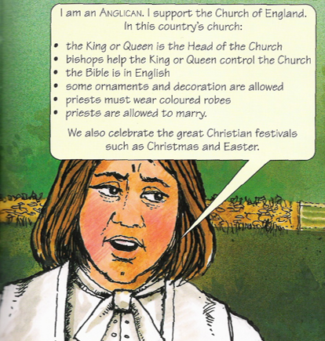
When has been the best time to be a Protestant between 1509 and 1558? Why?

When has been the best time to be a Catholic between 1509 and 1558? Why?

Elizabeth I is about to succeed her sister Mary to the throne. You are her religious advisers and wish to promote tolerance and peace between the two religions.
How would you try to achieve this? How do you think that ordinary people should be allowed to worship? Would you make any further changes to the churches in England?

_______________________________________________________________________________________________________________________________

_______________________________________________________________________________________________________________________________

_______________________________________________________________________________________________________________________________

_______________________________________________________________________________________________________________________________

_______________________________________________________________________________________________________________________________

