L.O To compare and contrast Catholic and Protestant Churches and worship
Look at the two types of church below.
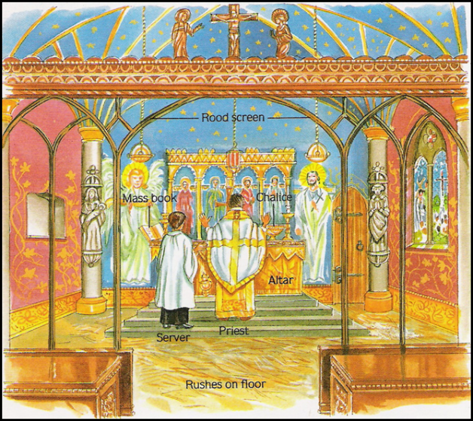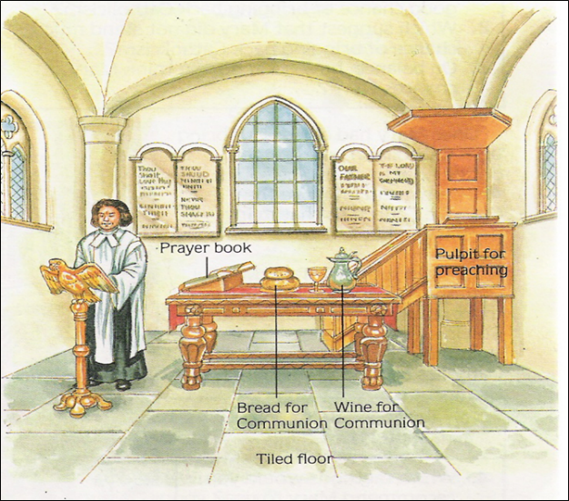
Catholic Church Protestant Church

Use the pictures above and the information about the reforms Edward VI made to the Church to fill in the table below:

Catholic | Compare/Contrast | Protestant
 | Leader/Head?
 | Altar?
 | Priests?
 | Decoration?
 | Prayer book?
 | Saints?

